WEB DESIGN
FINAL EXAM

Course | Web Design
Exam Type | FINAL EXAM
Duration | 2 hours
Generation | GEN-11
Date | Dec 30th 2025
Exam Rules | - All documents allowed  - The following actions are forbidden and will conduct to a 0 score:  - Talking or exchanging information with another student  - Using Internet or any Network

Evaluation

PART A – CONCEPTUAL UNDERSTANDING
Exercise 1 | MCQ | 10 points
Exercise 2 | Open Questions | 20 points
PART B – CODING PROBLEMS
PROBLEM 1 | Layouting | 20 points
PROBLEM 2 | Responsiveness | 20 points
PROBLEM 3 | JS | 30 points

To submit
- Submit this document AND your code (ZIP) on MS TEAM

PART A – CONCEPTUAL UNDERSTANDING

EXERCISE 1 (10 pts) MULTIPLE CHOICE

Q1 - What’s wrong with the following code?

<ul>
<li>Item 1</li>
<li>Item 2</li>
</ul>
<ol>
<li>Step 1</li>
<li>Step 2</li>
</ol>
(A) <ul> and <ol> tags should not be mixed on the same page.
(B) There is nothing wrong with this code.
(C) The list items inside <ol> should start at <li value="1">.
(D) Both lists should be <ul> to keep the same style.

Q2 - Which unit is relative to the font-size of the root element (<html>)?

(A) %
(B) rem
(C) em
(D) vh

Q3 - You want to align all items inside a container to the center both vertically and horizontally. Which option describes the correct approach?

(A) display: flex; justify-content: flex-start; align-items: flex-start;
(B) display: flex; justify-content: center; align-items: center;
(C) display: grid; justify-items: center; align-items: center;
(D) display: flex; justify-content: space-between; align-items: stretch;

Q4 - How many columns and rows will the following grid have?
.grid-container {
display: grid;
grid-template-columns: repeat(3, 1fr);
grid-template-rows: auto 100px;
gap: 20px;
}

(A) 3 columns and 2 rows
(B) 3 rows and 2 columns
(C) 2 columns and 3 rows
(D) 2 columns and 3 rows with gaps

Q5 - What background color will the .card element have when the screen width is 900px?
.card {
background-color: white;
}

@media (max-width: 800px) {
.card {
background-color: lightblue;
}
}

(A) White
(B) Lightblue
(C) Gray
(D) Transparent

Q6 - You want the .container element to change its background color to lightblue when the screen width is 768px or smaller.
Which of the following CSS code snippets correctly achieves this behavior?
(C)
.container {
background-color: lightblue;
}
@media screen 768px {
.container {
background-color: white;
}
}

(D)
@media (width <=768px) {
.container {
color: lightblue;
}
}
(A)
.container {
background-color: white;
}
@media (min-width: 768px) {
.container {
background-color: lightblue;
}
}

(B)
@media (max-width: 768px) {
.container {
background-color: lightblue;
}
}

Q7 - Which combination of design choices best supports a CALM and MINIMALIST website personality?

(A) Bright contrasting colors, heavy shadows, many icons, and tight spacing
(B) Neutral color shadows palette, generous whitespace, simple typography, and soft
(C) Multiple font styles, playful illustrations, bold colors, and animated icons
(D) Strong gradients, sharp border-radius, dense content, and high visual complexit

Q8 - Which Tailwind CSS class combination correctly creates a centered button with padding, blue background, and white text?

(A)
<button class="center padding blue text-white">
Click me
</button>

(B)
<button class="flex justify-center items-center p-4 bg-blue-500 text-white">
Click me
</button>

(C)
<button class="align-center pad-4 background-blue color-white">
Click me
</button>

(D)
<button class="btn btn-primary">
Click me
</button>

Q9 - What will be the output of the following JavaScript code?
let x = 5;
if (x > 3) {
x = x + 2;
} else {
x = x - 2;
}
console.log(x);

(A) 3
(B) 5
(C) 7
(D) 10

Q10 - Which of the following JavaScript statements correctly selects an element with the id "myButton" and changes its text to "Clicked"?

(A) document.getElement("myButton").text = "Clicked";

(B) document.getElementById("myButton").innerText = "Clicked";

(C) document.querySelector("#myButton").textContent = "Click";

(D) document.getElementsByName("myButton").value = "Clicked";

EXERCISE 2 (20 pts) OPEN QUESTIONS

Q1 - You need to apply a style to five elements on a page. Would you use a class, an ID, or a type selector? Explain your choice and discuss the potential advantages and risks of each method.

I would use class rather than Id because it would be easy for me to control all elements and I can use Id to control the specific item that I want to control inside class.

Q2 - You are tasked with designing a button with an exact width of 100px, including padding and borders. Which box-sizing mode should you use, and why?

I would use border-sizing rather that box-sizing because

Q3 – You are creating a photo gallery. Would you use Flexbox or Grid for the layout? Explain your decision, considering alignment, and responsiveness.
I would use grid because it easy to manage layout and I can decide how many column I want my picture to display it’s flexible because “span” I can decide how big or how small to didplay the picture

Q4 – You need to add space between a button and the text above it. Should you use margin or padding on the button? Justify your choice.

I would use margin because margin control space outside the content but padding control space within the content so using padding is useless if you want to add space between a button and the text above it

Q4 – Here is a website folder structure.

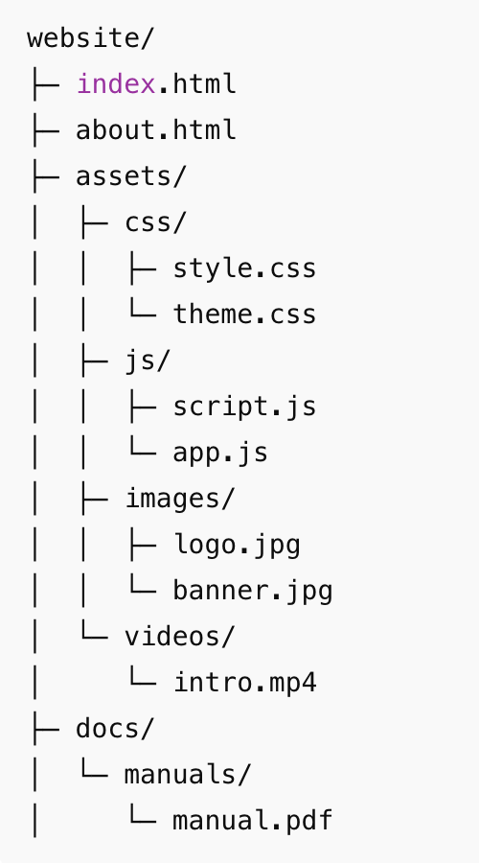

Fill up the table with the hyperlink, so that we can create an anchor link from the source folder to the destination file.

PATH TYPE | SOURCE FOLDER | DESTINATION FILE | HYPERLINK LINK
ABSOLUTE |  | script.js | href=website/ asset/js/script.js
RELATIVE | website/ | style.css | href= asset/css/style.css
RELATIVE | website/docs/ | manual.pdf | href= manuals/manuals.pdf
RELATIVE | website/assets/videos/ | intro.mp4 | href= intro.mp4
ABSOLUTE |  | intro.mp4 | href= website /asset/videos /intro.mp4

PART B – CODING PROBLEMS

PROBLEM-1 – LAYOUTS – 20 POINTS

Design a simple Facebook-style post layout using HTML and CSS (Flexbox and/or Grid).

NOTES:

- You can use regular CSS or Tailwind CSS
- Use a fixed post container size of 400px width (height auto or around 450–500px)
- Use Emojis as button icons.

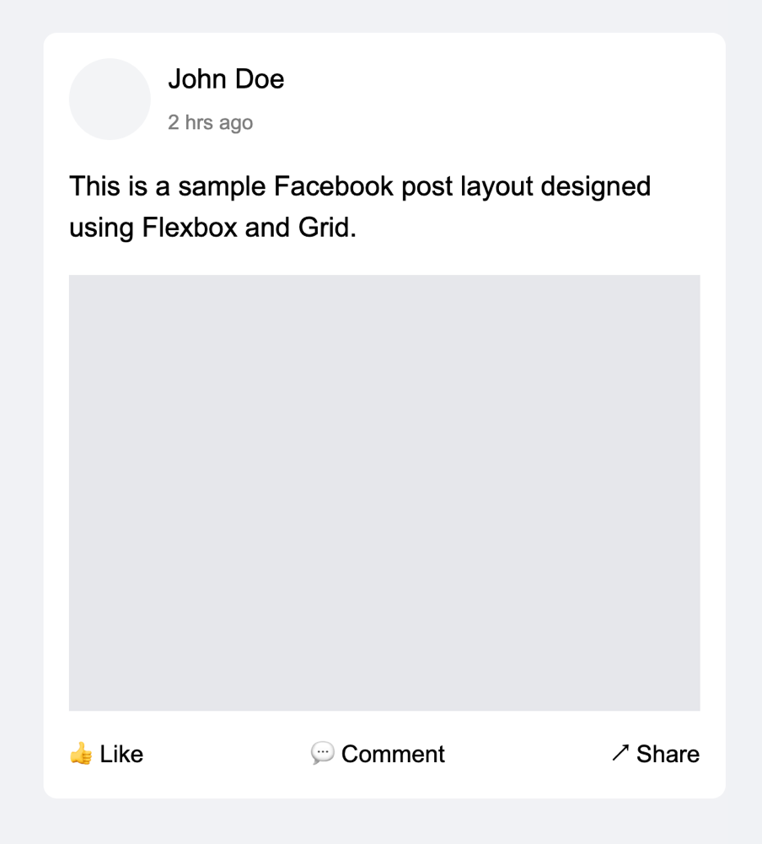

PROBLEM-2 – RESPONSIVENESS – 20 POINTS

Create a single HTML file that implements a responsive web page layout matching the provided wireframe.

NOTES:

- You can use regular CSS or Tailwind CSS

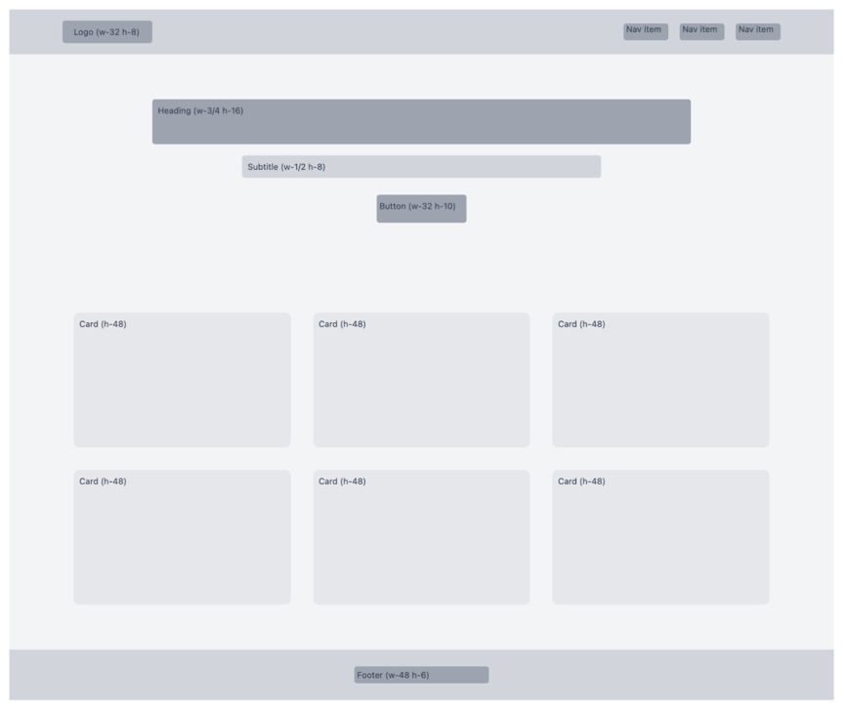
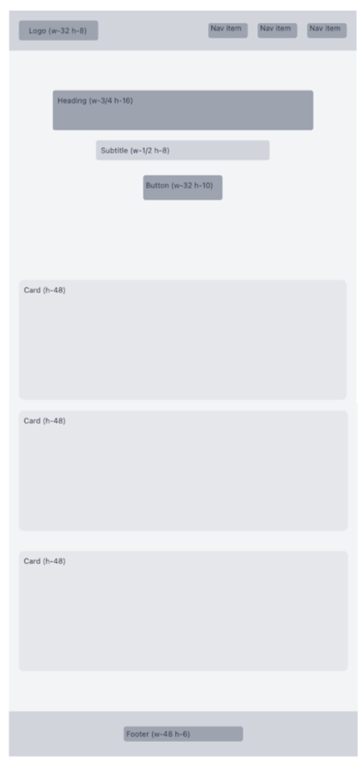

PROBLEM-3 – JS – 30 POINTS

- Create a simple web page using HTML, CSS with 3 tab buttons, and a paragraph description.

- When user clicks on a tab button, use JS to update the paragraph description accordingly

NOTES:
- You can use regular CSS or Tailwind CSS
- Use Emojis as button icons.





